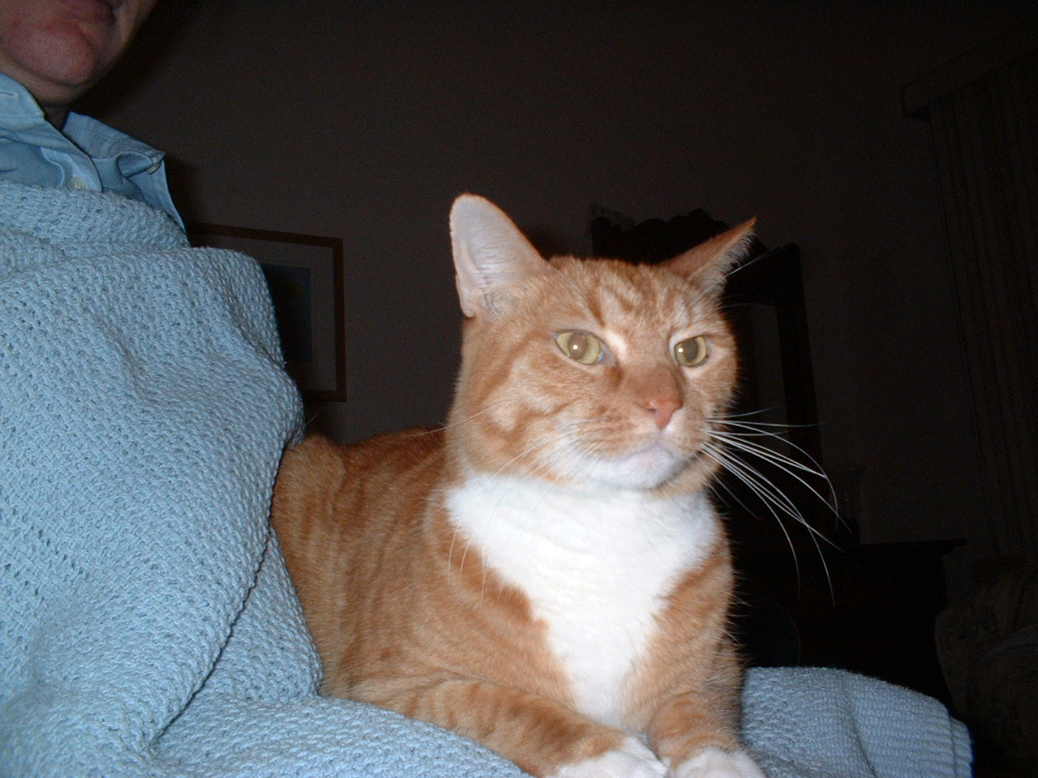 | Tomato: It took a really special person to adopt me - I have diabetes insipidus - my body doesn't know when to stop making urine. So I need 2 shots a day (timing doesn't matter on the shots which makes it easier). Anyway I love dogs and sometimes male cats challenge me and female cats beat me up -- so PAWS really had their work cut out to find me a home! Well a home found me...a nice lady needed a companion cat for her dog...and the lady isn't afraid of giving shots...so off I went to my new home! Yay!
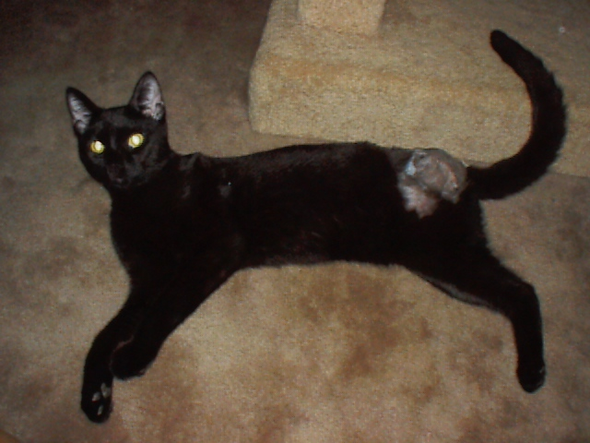 | Charlie: DOB approx Sept 2003 DSH black neutered and front declawed male. He was found 2nd week of June in a downtown Cocoa business parking lot with a broken leg. Leg could not be set as the break was weeks old, so we had to amputate. This is one of the nicest cats and he doesn't even miss his rear leg - he and the other young adults have a great time wrestling around on the floor! His amputation was expensive, so if you can donate toward the cost it will help us a lot! This cat is SO nice he found a home within 3 hours of his first visit to PetSmart -- and with only 3 legs!
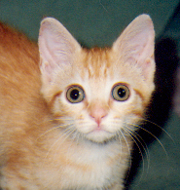 | Goldie: I'm a special needs kitten. I was born with brain damage and I'm visually impaired. I got a great home and now I have a new brother who is also blind. We are best friends now and we play with each other and cuddle together all the time.
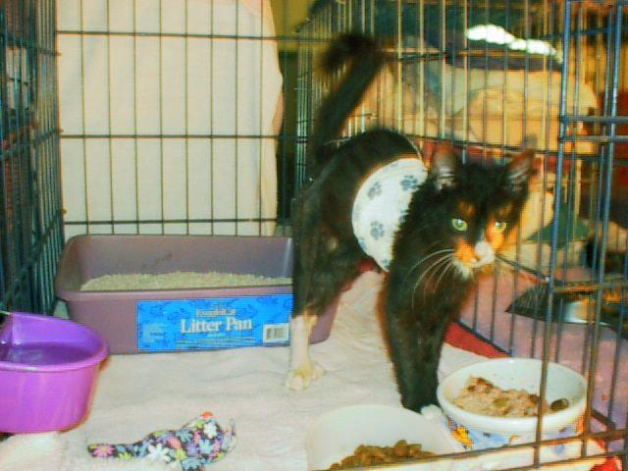 | Rally: Wow what a story I have. I was found nearly dead from dehydration on US1 in Melbourne. Lucky for me it was a clinic Sunday at the Eau Gallie shelter, which means a no-kill group was there (fixing feral cats). The vet tech, Tina, took me in and hydrated me, and from there on out, I improved by leaps and bounds. I had a broken leg, mange, and an upper respiratory infection. Tina took me to Mona, and Mona got my leg fixed (pinned, not amputated, we went the expensive route). I found a GREAT home where they changed my name to Riley (as in Life of...). I'm happy as a clam now because I have Smithers to play with (yes they came and got me a buddy when my play got too rough for those thin-skinned humans). I'm a happy boy!
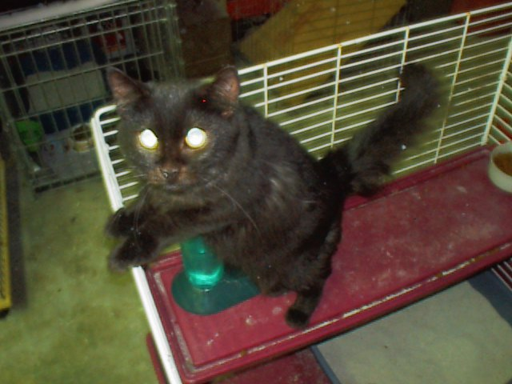 | Sofie: DOB approx June-July 2003. DMH black, we are pretty sure she is a Norwegian Forest Cat mix. She was abandoned by her family after they dropped a couch on her head and left her unconscious for 3 days (that's what we were told at the vet). She was given to a "friend of a friend" who worked at a vet, to see if she would live. Obviously the owners didn't want her back. The vet asked around for rescues to take her. She is brain damaged enough from the concussion to be considered special needs. She is fine with other cats. Sophie is very sweet and loves to play. She does not like to be groomed, and will not groom herself, so we would take her to the vet for a lion cut every summer (she loves the freedom from that double coat). Due to these challenges, it was very unlikely Sofie would ever be placed into a private home. She would be living in a foster room for the rest of her life. Then, in Feb 2006, a very nice couple wanted to adopt Sofie! Emails flew back and forth as the adoption day loomed closer! Then came the big day - Sofie went home! We are sure everything will go perfectly well, and Sofie will love her new home! :)
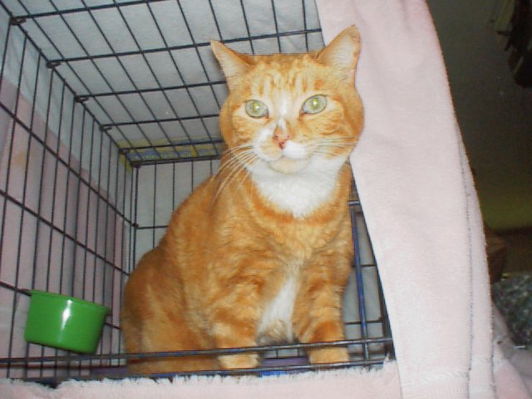 | Tom: I had to go to a barn home because I like to spray :( But I have twenty+ acres to romp around on...I'm doing GREAT!!

