
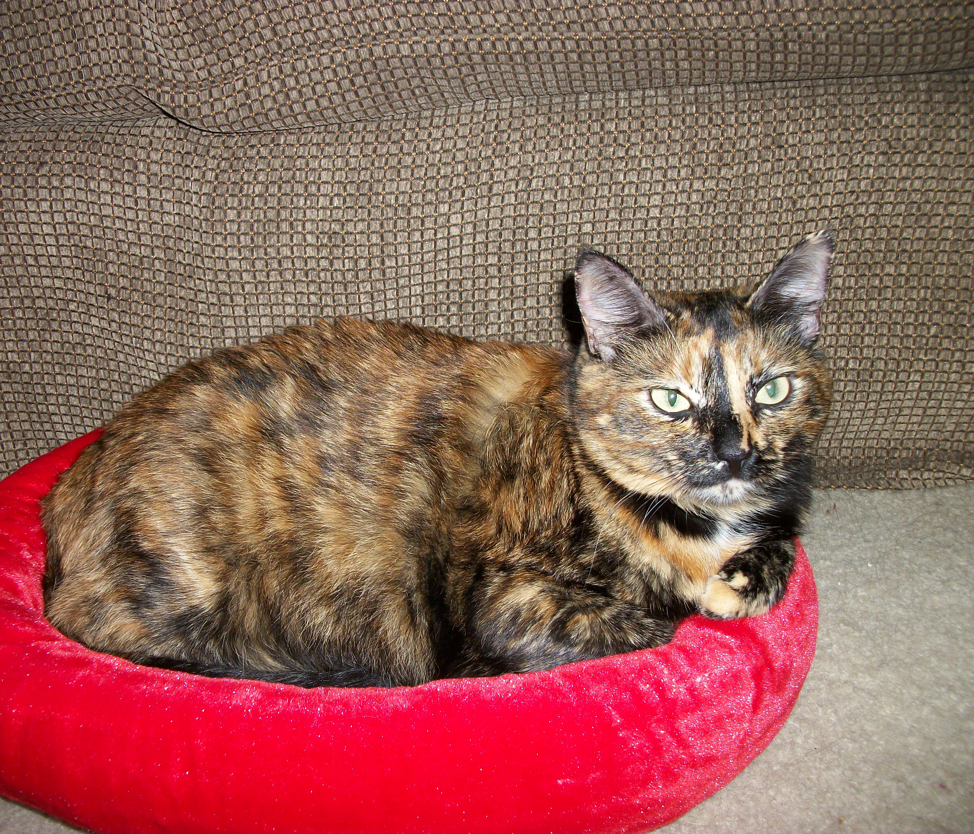 | Madilynn: Here's what my new Mommy says about me: "I was looking for a companion that my 5 1/2 year old cat would get along with and for a lap kitty for myself. Madilynn came into our family and now Nina has not only a companion but a play buddy. They even sometimes sleep together, and both seem very happy. Nina had just not been the same since our old cat died. It is nice to see the old Nina back. I also got the lap kitty I wanted. Madilynn loves attention and pettings, and as soon as I lay down, she's looking to lay on me. She is a perfect fit for our family." UPDATE: I’ve been fattened up after weighing only 6 lbs right after having 5 babies (all of whom found homes through PAWS). I love my food and am much happier now.
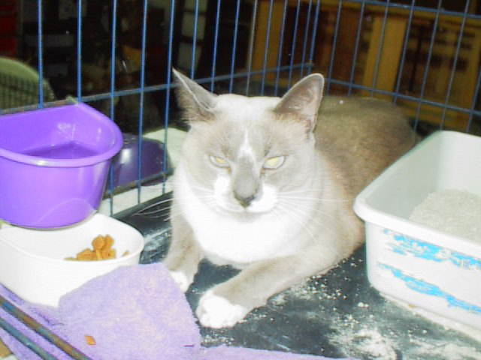 | Skippy Jr.: Skippy's family had to move and couldn't take her. She was originally adopted thru PAWS, so she was returned to PAWS and found a home very quickly -- she's a very nice girl!
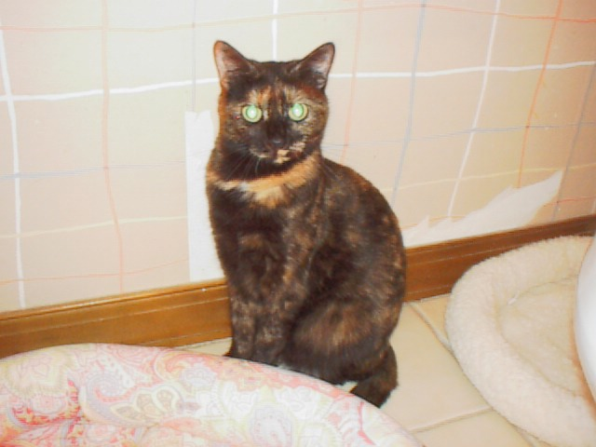 | Venus: I am one of the sweetest torties PAWS has ever fostered. I'm a bobtail so am extra special (the Manx gene) and friendly. My new owners and my foster mom were old co-workers, and were surprised to see each other at PetSmart, and I ended up going home with my foster mom's friends. Funny how that worked out! I have a great place to live, a porch with all that a cat could want, and lots of other cats (did my foster mom mention that I am a "drop in" -- I get along immediately with all cats).
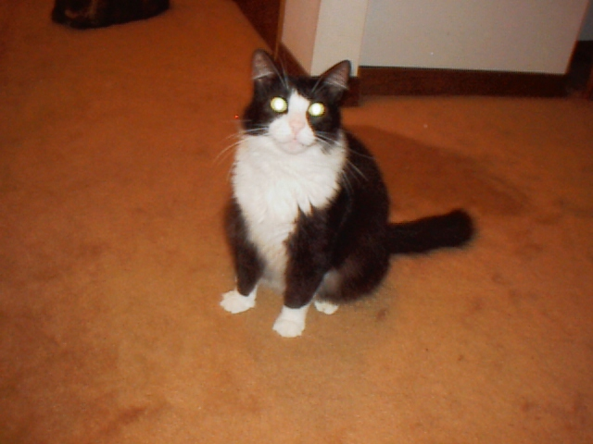 | Oreo: What a super home I got. I'll be top cat with a visiting cat every once in awhile (that's okay). My new mom is young and pretty, and fell in love with me at PetSmart! My new mom later went back to PAWS and got me a new kitten to play with, her name is Lily (PAWS had named her Safi) and she is my best buddy. We are buds now! My mom sends the PAWS foster mom updated pictures all the time of us!!
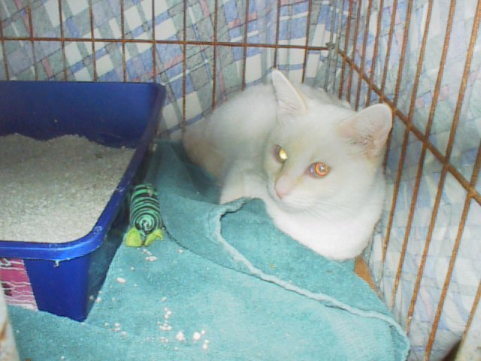 | Fredrica: I got the absolutely BEST home. My new owners had done TONS of research (did you know only 10% of flame point Siamese cats are female???) and they were extremely concerned about how to introduce me to their existing kitty. They knew all about Nutro food, and were very thorough with questions and made sure I was the right cat for them!!! That's the kind of good, loving home I need....I am gonna love it at my new home!
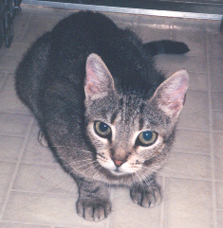 | Abigail: I was very shy, but my new Mom had faith in me. After two months, I am queen of the house and I even play chase with the dog. (Of course, I like it better when I'm the one doing the chasing). My new family thinks I am great, including the dog!! You see, even us shy guys can make great pets if you give us a chance!!
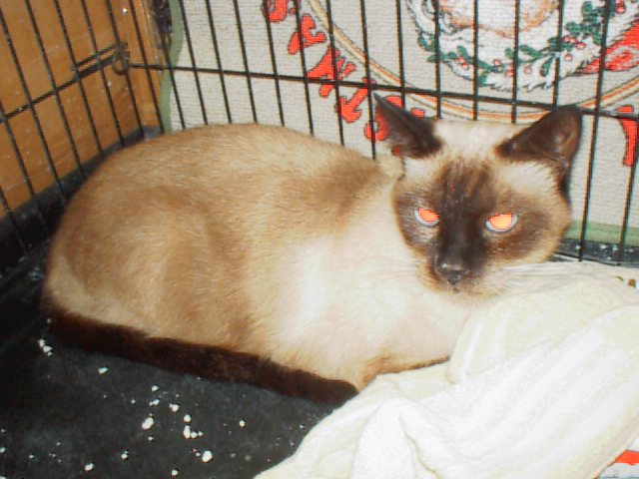 | Arthur: I got a GREAT home. I am not used to being outside a cage, and I don't like being picked up, and believe it or not, I don't know how to play....BUT in spite of all that, a nice lady from St. Augustine (!) came and adopted me, and will spend the time with me to make me comfortable in her home. Yoyo!
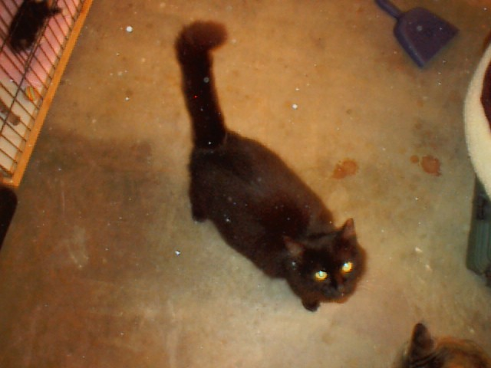 | Marissa aka Mama: I was a neighborhood stray who was fixed by the county (thus my slight ear tip). I got dumped at the shelter just a little while after that, the neighbors were sick of seeing so many cats outside. So it was my lucky day when PAWS took me in. I am so sweet, I took care of all the kittens in the foster room, and I love attention, so I was easy to place.
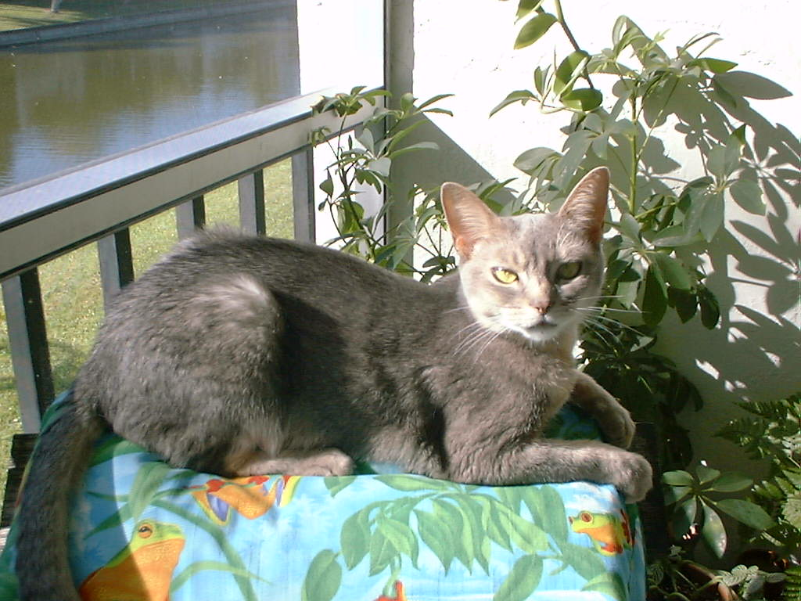 | Misty Blue: I've had a tough time! My original owners dumped me, so the neighbor took me in. Her cat beat me up all the time, so I got adopted from PAWS. Then my new owner passed away suddenly (just 3 months later) and PAWS took me in again! So, I found my new home already and I'm happy again!
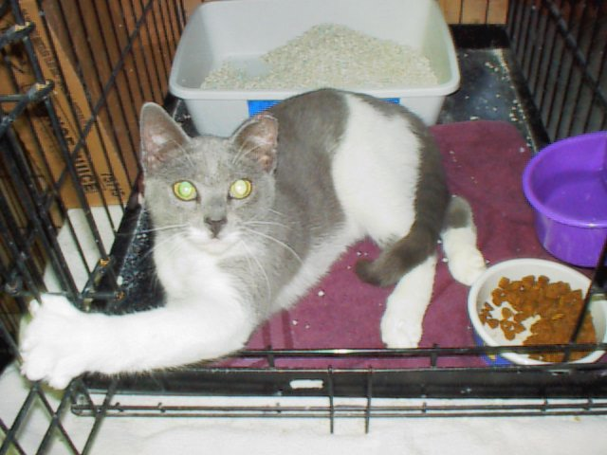 | Shiloh: I was pulled out of a trailer park in Dec 2003, fixed, placed, and dumped at a kill shelter when the lady who adopted me decided just a few days later she didn't want me anymore! (She didn't even read on the no-kill contract to return me to the no-kill folks). PAWS bailed me out of the kill shelter, and I got another home, then they had to move?!?!?! What is THIS?? Can't take the cat with you? Since when? Well, so PAWS again took me in and found me the BEST HOME YET (in my case I can say that, right?) Thanks, PAWS
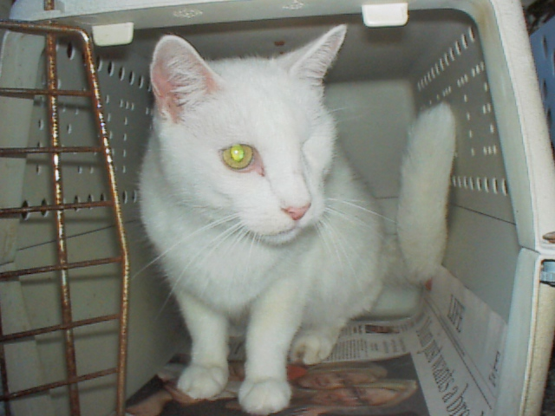 | Aubrey: I got a great home with my foster mom's sister. She loves me a lot. I was at the kill shelter about to be put down - I was declawed and had only one eye! Thanks PAWS for saving me!
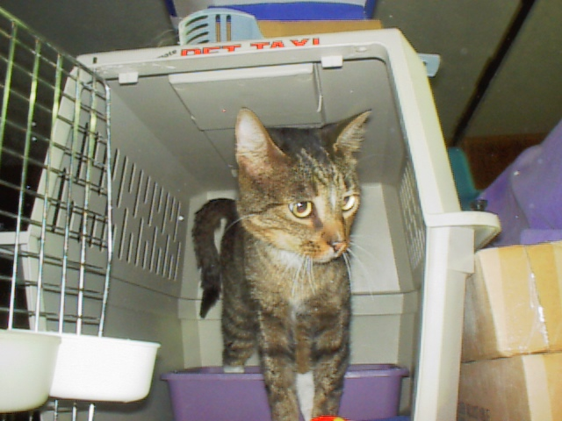 | Gilligan: I was named Gilligan because I was found on an uninhabited island off the coast of Merritt Island, luckily a man took his dog there to run one day and there I was, hungry and thirsty. I was already neutered and declawed and PAWS took me in to get my shots and tests done. I was very friendly and got along fine with all other cats. I checked out fine at the vet, and found a home on my first trip to PetSmart!
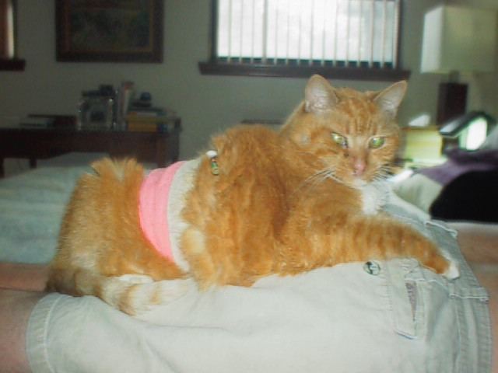 | Penny: After 6 months in rescue, the most amazing person called about this 22-year-old cat. It takes a VERY special person to adopt a cat like Penny. We salute you, Sandy Leonard!

