As a cat owner for over 11 years, I have found several solutions that have worked for me personally. For those who say I have asthma or allergies and have to get rid of or cannot adopt a cat, there a few options you can try if you’re willing to give it a shot. I used to test as a 4+ (the highest rank possible) when they tested me for cat allergies. I also suffer from Allergy induced Asthma. I wouldn’t give up my cats, so I found ways to deal with the issue. I was a 1+ (a very slight allergy) my last allergy test. I take a generic allergy pill once a day before bed and I don’t take allergy shots. If you feel a need to or your doctor recommends it, by all means use allergy medications and/or shots, but if you’re against them or would prefer to go another route, why not try some of the tips listed below. I have no medical background and am just someone who has adopted and fostered cats, but I have found the methods below to be extremely helpful. I have had up to 4 cats at one time between personal and foster cats, and my cats sleep with me in bed every night, with one right next to me.

The first thing I recommend is to make sure both your vacuum and air filter contain HEPA filtration. Vacuum at least once a week (I use a Bissell PowerForce) if possible and don’t forget the furniture. Change you’re A/C air filter once every 1-2 months instead of every 3.
Also, regular brushing or combing of the cat(s), as much as can be managed per day or week, to reduce loose fur left around the house (better if done by someone not allergic to the cat, but if no other option, do it yourself – I do). This also has the added benefit of reducing hairballs.
Pledge now makes a Dust & Allergen formula that can be used on household hard surfaces. For soft fabric surfaces like couches, chairs, and carpets try Febreeze Allergen spray.
If the cat(s) will be with you when you sleep or in your bedroom, you can use an ionizer if needed and keep it on at all times. Ionizers can be used in any room your cat(s) and you frequently spend time in together and come in different sizes for different sized rooms.
The below picture is of a cat shampoo I think works wonderfully at reducing cat dander – Simple Solutions Dander Reducing Serum. Cats and baths, no way right! Here’s the great part: you take and wet a washcloth with it and rub the washcloth on the cat just enough to dampen the cat’s fur and then let the cat go. I usually wet a washcloth with warm water, squeeze it out, and then add a generous squirt of the Dander Serum. In order to contain them, I lock my 2 in the bathroom with me and rub them down before I do their monthly flea treatment, and then let them go. If your cats will let you, I follow up with a brushing or combing. I have used this shampoo for 11 years and I love it. You can use this as frequently as once a week.
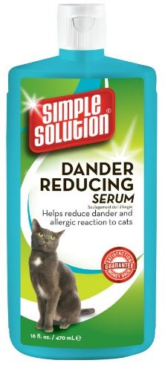
Fell free to try as many or as few of this tips as you like in order to cope with cat allergies.

